■ Special Edition on Car Purchase Trends
- Trends in New Car Purchasers by Age
- Purchased Car Type Trends
- Fuel Type Trends(Electronic cars, hybrids, etc)
- Car ownership trends (rent, sharing, subscription, etc)
Automotive Consumer Reports 19/20-1 ;
50s and 60s pushing out 20s and 30s as a big hand in the new car market

- Rapid generation replacement after the emergence of the smartphone
- 20s and 30s overtaken by 60s and 50s, respectively
- Need to prepare for a cataclysmic change in terms of Purchase, Ownership, and Consumption
Since the emergence of smartphones in 2010, the automobile market has been changing rapidly. The purchase of cars by younger generations has shrunk dramatically with the portion of the car purchase by those in their 50s getting bigger. Only in 7 years, those in their 30s as a big hand in the car purchase market have been overtaken by those in their 40s and 50s, and those in their 60s also yielded their place to those in their 20s. Behind all these changes, there are cultural aspects featuring smartphones as well as economic and demographic reasons.
ConsumerInsight, an automobile research expert, has been carrying out a large-scale syndicated automobile survey with approximately 100,000 respondents per study every July since 2001. Its eight studies since 2011 show new car purchasers by age in the past one year as follows [Figure 1].
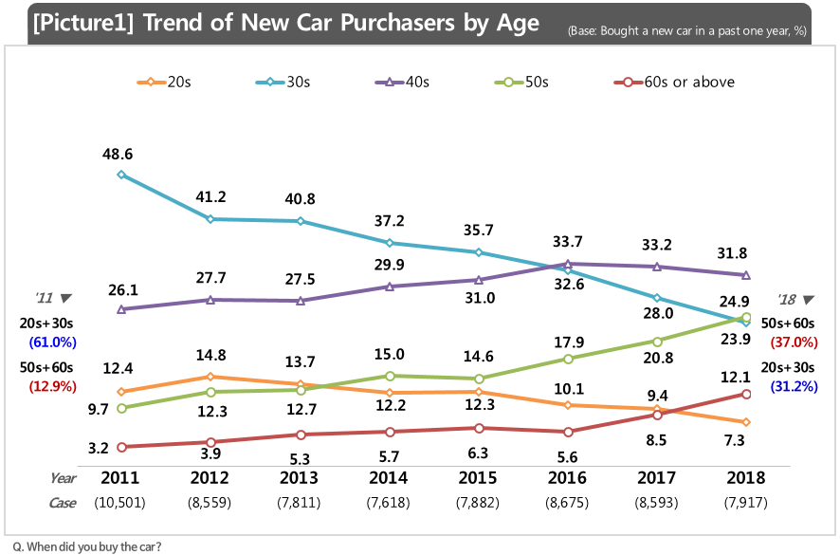
The most noticeable is that the purchase share of those in their 30s that used to be the big hand of the new car market decreased to half in 7 years (48.6% to 23.9%), pushed back to the third place by those in their 40s to 50s. Those in their 40s grew steadily, surpassing those in 30s in 2016 to No. 1 (31.8%)
while those in their 50s started at less than 10% but grew 2.5 times in 2018 to 24.9%. Those in their 60s rose to 12.1% after surpassing those in their 20s in 2018 since their mere start at 3.2% in 2011.
Consequently, the new car purchase share of those in their 20s and 30s was cut down to 31.2%, the half of their 61% in 2011, with those in their 50s and 60s having increased triple times from 12.9% to 37% during the same periods of time. The place of those in their 20s and 30s and those in their 50s and 60s has been completely shifted around.
These changes in the trends can be attributed to the reduced necessity of cars and the purchasing power of the young generations because of their delayed financial independence, marriage, and low birth rate. The consumers’ needs for cars have been reduced greatly with the increase of cultural alternatives to enjoy, such as games, social media, and arts, etc, along with the emergence of transportation applications that help choose various transportation means.
In addition, with the pursuit of new values such as ‘YOLO’ and ‘Sohwakhang,’ such expensive items as house, cars have been naturally even more burdensome. After sensing the digression of those consumers in their 20s and 30s, car manufacturers appealed their ‘bigger,’ ‘safer,’ and ‘more expensive cars’ to those in their 50s and 60s with affluence, accelerating the changes of the trends even more.
Car buying trends are facing a dramatic change and the same is still under way. The automobile industry is to address the agenda of 'green', 'autonomy', and 'sharing' in the near future. The future of the automobile market will also be depended upon how to meet these challenges.
==============================================================
◈ Reference: 「Consumer Insight」 Annual Automobile Syndicated Study Outline
The contents was excerpted and summarized from the results of ‘Annual Syndicated Automobile Study’ conducted by Consumer Insight Inc. in every July since 2001.
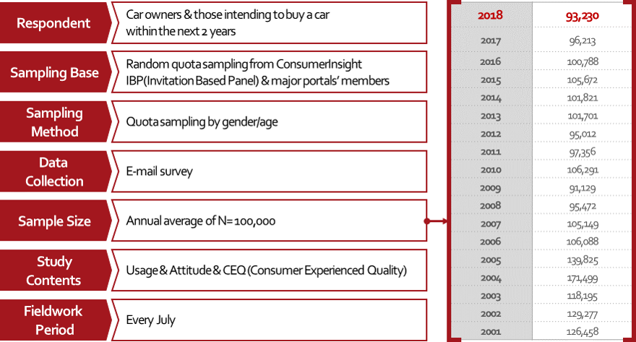

*Appendixes
